 | Recycle For  Breast Cancer
“Support a Worthy Cause and Help Protect the Environment.”  Announcing a New Recycling Program to Benefit the Fight Against Breast Cancer.  By making this small commitment everyone can make an impact on the lives of others.  Contact us for more information and to become involved in this important program. | Fight Breast Cancer by Recycling Printer Cartridges & Cell Phones  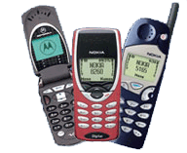  Every day millions of cell phones, pagers and printer cartridges end up in our landfills. Recycle for Breast Cancer is committed to raising money to help the fight against breast cancer while helping to preserve our planet’s natural resources.  We encourage you to get involved and start recycling your Cell Phones, Pagers, Palm Pilots, empty Inkjet and Toner Cartridges from your printers, fax machines and copiers. These items can be recycled individually or in bulk.  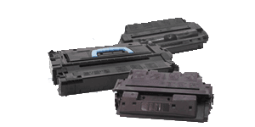  To assist you in your collection efforts we can provide free pick up, pre-paid envelopes or pre-paid shipping labels. There is NO COST to you. For each item recycled, a donation will be made to the Breast Cancer Foundation.  It’s Easy to Participate  1) Tell the staff about this program. 2) Start collecting cartridges and cell phones from your home or office.  3) Call for FREE shipping labels. 4) Continue to collect all year long.  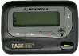  START COLLECTING TODAY!  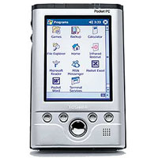  Recycle for Breast Cancer  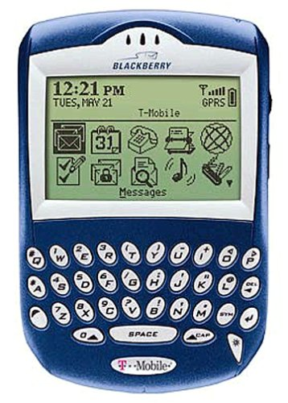  Larry Behrens, Program Manager  Phone 925.735.7203  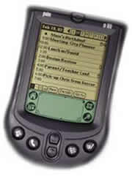  larry@recycleforbreastcancer.org  www.RecycleForBreastCancer.org  